JOIN VIA WEBEX DESKTOP APP

OPEN WEBEX APP
Click WebEx App

1

FIND AND OPEN WEBEX APP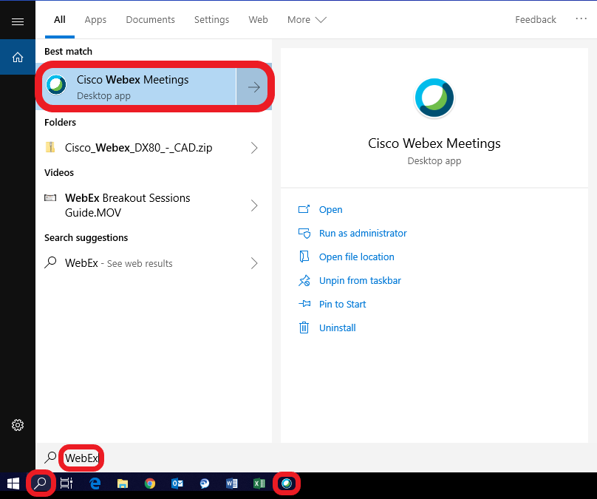
Click Search

1
Type WebEx

2
Type WebEx

3

SIGN IN AS GUEST
If you do not have a WebEx Account
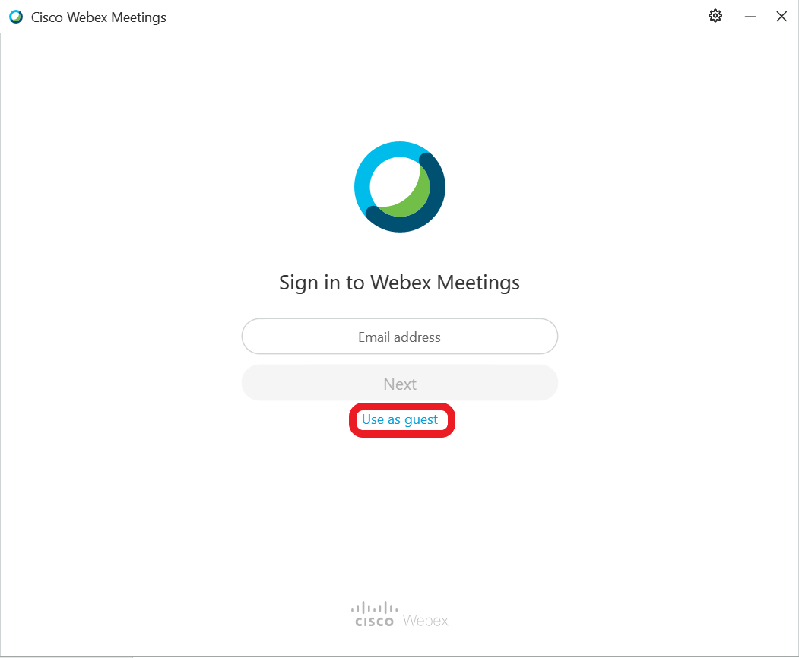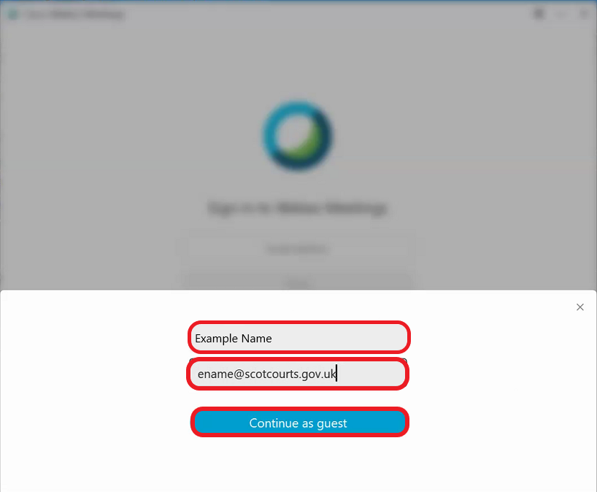

2

4

3
Enter your name
Enter your email address
Click Continue as guest
Click Use as guest

1
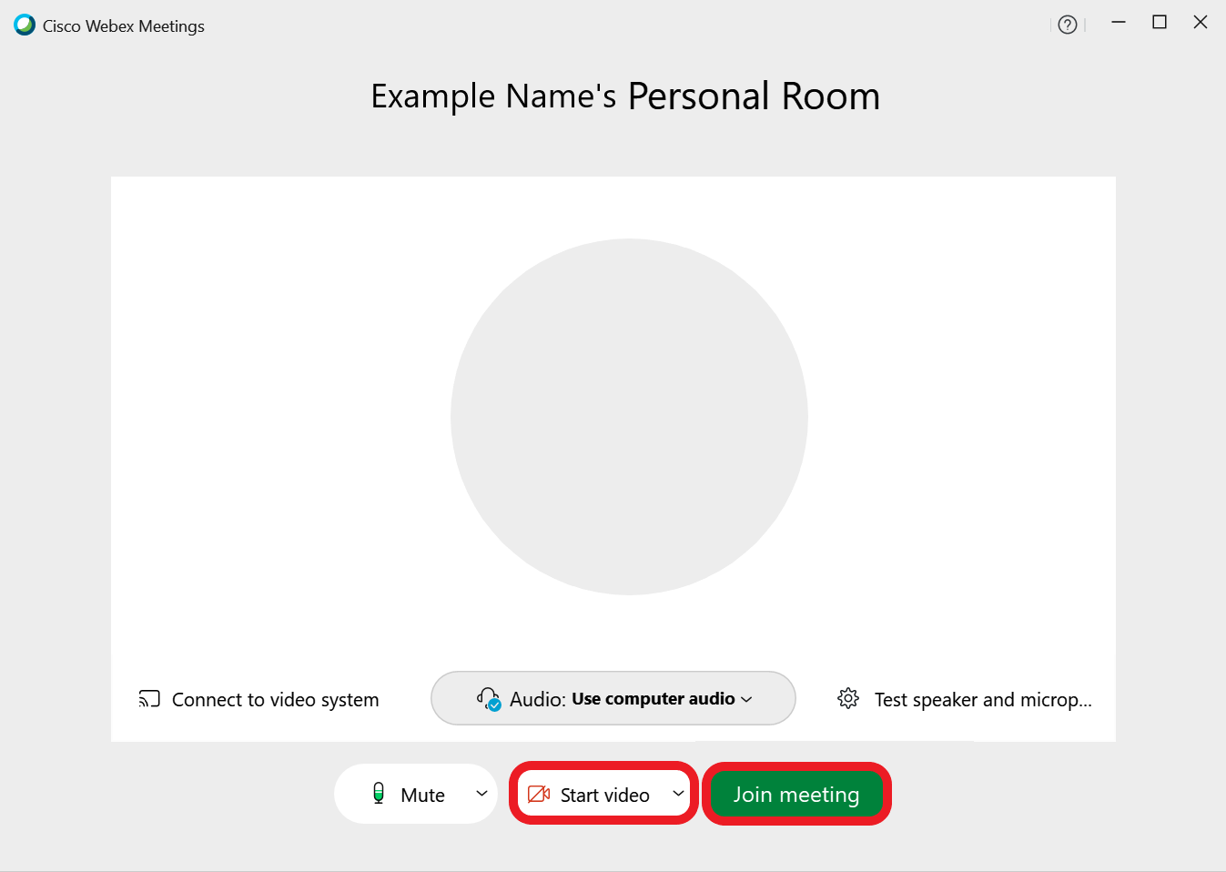
Click Start video

5
Click Join meeting

6

SIGN IN
If you do not have a WebEx Account
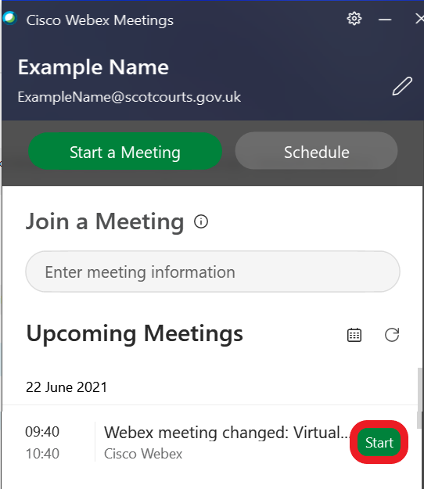
Click Start

1
Click Start video

2
Click Join meeting

3

JOIN VIA MEETING NUMBER

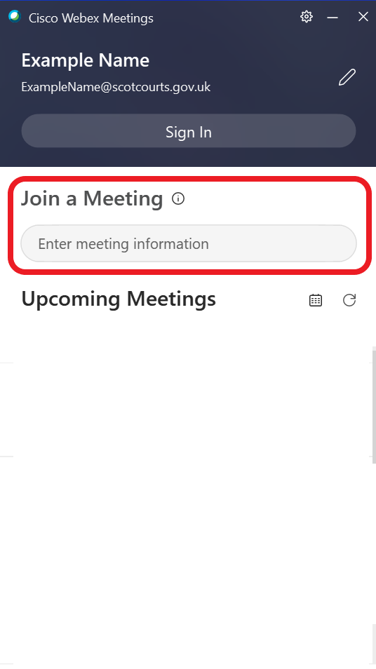
Enter meeting ID

1
Click Join

2
Click Start video

3
Click Join meeting

4

JOIN VIA EMAIL INVITE

1
Open meeting in email calendar
Click Join meeting

2
Click Start video

2
Click Join meeting

3

LEAVE A MEETING
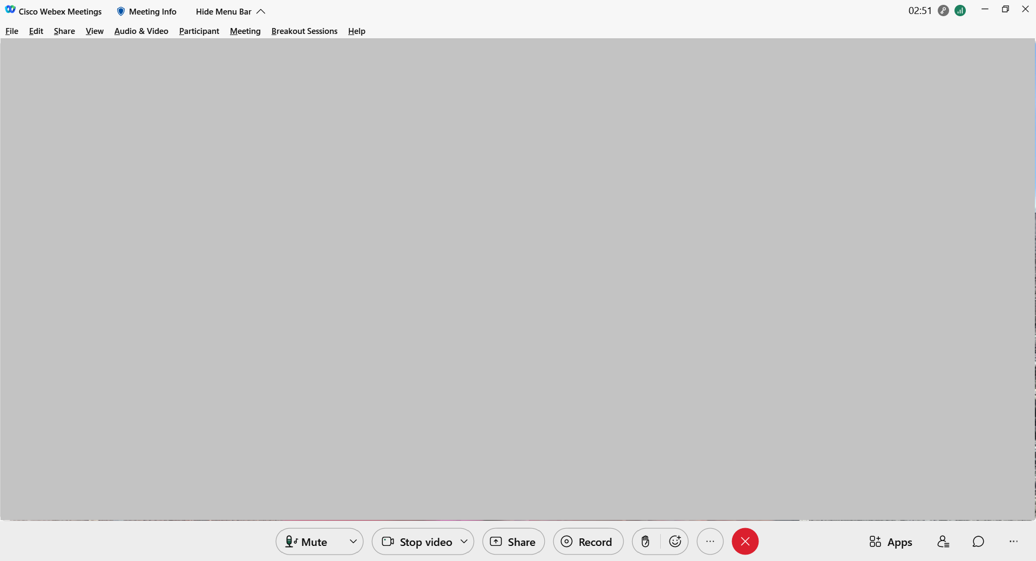
1

Click here and follow the instructions

